# 

# AMERICAN UNIVERSITY OF BEIRUT

## Faculty of Engineering and Architecture

*Department of Mechanical Engineering*

## MECH-341: Materials Laboratory

## Report 5

## Section-4

## April 1, 2009

### Instructor: Mr.Cherbel Seif

### Group members:

### Table of Contents

1. Objective………………………………………………………….……….3

2. Introduction………………………………………………………………..3

3. Problem approach………………………………………………………….4

4. Analysis and calculations………………………………………………….6

5. Observations……………………………………………………………....9

6. Conclusion……………………………………………………………...…10

7. References…………………………………………………………………11

8. Appendix......................................................................................................11

1. Objective

The aim of this experiment is to determine the fatigue life of an aluminum notched bar before it reaches the fatigue failure.We will also determine from the measured values various properties of the given specimen. Moreover, to determine the effect of notching the specimen on the fatigue life.

1. Introduction

Most machinery and many structures do not operate under a constant load and stress. In fact, these loads and stresses are constantly changing. A good example of this is a rotating shaft such as the axle on a railroad car. The bending stresses change from tension to compression as the axle rotates. This constant change in stress can cause fatigue failure in which the material suddenly fractures. The process that leads to fatigue failure is the initiation and growth of cracks in the material. Fracture occurs when the crack grows so large that the remaining uncracked material can no longer support the applied loads.

Basic fatigue testing involves the preparation of carefully polished test specimens (surface flaws are stress concentrators) which are cycled to failure at various values of constant amplitude alternating stress levels. The data are condensed into an alternating Stress, S, verses Number of cycles to failure, N, curve which is generally referred to as a material’s S-N curve. As one would expect, the curves clearly show that a low number of cycles are needed to cause fatigue failures at high stress levels while low stress levels can result in sudden, unexpected failures after a large number of cycles.

1. Problem Approach

In this experiment, we want to test a specific characteristic of the material. As in previous labs, we were testing the material to use it in the design stage. We want to make sure that the design won't fail. Previously we have tested the material under static loading. But, this is not enough, we must also test the material not only under static loading but also under variable loading (cyclic loading). The characteristic of the material to stay without fracture for a period of time is the fatigue factor. Fatigue is defined as the time that the material could withstand a certain cyclic loading without fracture. For this experiment, there are many testing machines which use different methods.

The fatigue test is in principle is rotating a specimen with a certain frequency of rotation while applying a cyclic stress on the specimen. The cycle of stress is applying a sinusoidal function of tension and compression on the specimen. Taking into consideration a certain point on the specimen where it is loaded, as the specimen rotates, the stress exerted on this point is tension when it is in the upper cycle and compression on the lower cycle. Figures 1 and 2 describe this phenomenon in a good way.



Concerning the testing machines, there are many testing machines for this test, two of the most common testing machines are Terco testing machine (Fig.3) and the rotating beam type testing machine proposed by R.R. Moore (Fig. 4). Anyway, in our experiment we are going to use a testing machine manufactured and calibrated at AUB. The UB fatigue testing machine is designed to apply the load on the middle of the specimen. The specimens used are of Aluminum Alloy of cylindrical shape and a diameter of 9.5 mm. A notch is applied on the middle of the specimen by a one mm depth. This notch is made to facilitate the crack initiation since fatigue failure is dependent on many variables which one of them is the material internal flaws and surface crack which the failure crack propagates through.

The procedure of the experiment is very simple. We put the specimen in the bearings of the machine, turn on the machine on a constant angular speed after we apply the load on the mid-section of the specimen. The load in this experiment is a mass of 20 Kg. The time when the failure occurs is recorded.



1. Analysis and Calculations

**Given:** - The weight of the load: 20 (kg) $×$ 9.81 = 196.2 N

* The diameter of the bar: D = 9.6 mm
* The radius of the notch: r = 1.2 mm
* The diameter of the notched part: d = 9.6 – 2.4 = 7.2 mm

**σmax = (Mc) / I**

*-M is the moment in the material at the section of the applied load.*

M = F $×$ s/4 = 6.25 N.m ,s=12.75 cm

-*c is distance from the neutral axis.*

c = d / 2 = 3.6 mm = 3.610-3 m

*-I is the moment of inertia section considered.*

I = d4 * π / 64 = 1.32 * 10-10 m4

* σmax = (6.25 3.610-3)/ (1.32 10-10)= 170.45 MPa ***(tension)***
* σmin = - 170.45 MPa ***(compression)***
* σm = 0
* Δσ= 170.45 – (-170.45) = 340.8 MPa
* σA = Δσ / 2 = 170.45 MPa
* R = σmin / σmax = -1
* **A is undefined.**

*A graph showing the variation of the stress the outer surface of the test specimen experiences during one rotation cycle at the notched part of the bar is given below:*

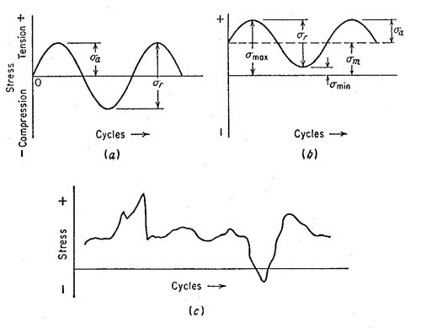

*Fatigue stress concentration factor:*

**Kf = σmax (notched specimen) / σmax (notch-free specimen)**

* σmax (notched specimen) = 170.45 MPa
* σmax (notch-free specimen) = (Mc) / I
* ( c = D/2 = 4.8 mm and I = D4 π / 64 = 4.1610-10)
* σmax (notch-free specimen) = 72.12 MPa
* Kf = 170.45 / 72.12 = 2.36
* Theoretically:

**Kf = 1+ (Kt -1)q**

r/d = 0.17 *D/d = 1.33*

Kt = 1.55

q = 0.55

**Kf = 1.30**

The relative error between the measured factor and the theoretical one is:

[Kf (measured) – Kf (theoretical)] / Kf (theoretical) 100 ≈ 81.54%

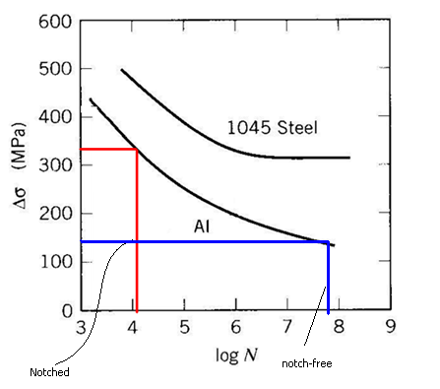

* N= fatigue fracture time $×$ revolution/min = 8.367(min) $×$ 2800 rev/min=**23,426.67 rev (cycle)**
* **log N = 4.37**

The fatigue life *N* indicated in the graph is close to the one obtained from “motor-rpm”

* As indicated in the graph the notch has an effect on the specimen fatigue life such that as the notch round radius increases the fatigue of the specimen will have shorted life than the notched specimen.

1. Observations

*\** The machine used is the AUB-built fatigue test. It first shows as a simple machine, with a motor, and a base holding to connections on top of it.

* The material used in this lab is aluminum. This is the first lab that we use aluminum as a tested material. It shows from the shiny color which all the materials we used before didn't have.

* As usual, the specimen has a small grove in its middle, or as it called a notched round bar. As before, the notch is to help the fatigue test to work on this specific area, for the fracture to occur in this area, else wise, any impurities or other small groves would be a good site for the fracture to happen. Thus a small notch guarantees the fracture to occur at that area.

* After the specimen is put in its place, a certain weight is suspended from it. This weight with the rotation of the specimen with the motor is what makes the fatigue test (this part is to be discussed in another section).

* The instructor suggested we use a 20KG load instead of 30 because in the previous test they conducted, it only took 16 seconds with a 30KG load to fracture.

* During the time the test is conducted, we can hear the sound of the motor, and a strange sound from the specimen which made us every time we heard it that it's going to fracture.

* Unlike other tests, the fracturing of the specimen doesn't produce a big noise compared to other experiments including fracture.

* What's most surprising is that the specimen fractures with no previous warning! That what makes fatigue in machines a dangerous effect that we need to take into consideration.

1. Conclusion

We noticed that the stress in notched rod is higher than the unnotched one. In addition, the time taken to fracture notched rods is less than the time for unnotched one. This what makes notched rods easier to be used in the experiment.

Therefore, under cyclical loading the specimen experiences fatigue and thus break at a stress lower than the maximum stress the material can sustain.

We can draw an inverse relationship between stress and number of cycles to fail, as stress increases number of cycle’s decreases. But as stress decreases number of cycles increase until it reach the minimum stress below which there is no failure.

1. References
2. Dieter, G.E., *Mechanical metallurgy*, 1988, SI metric edition, McGraw-Hill.
3. W.D. Callister, *Fundamental of materials science and engineering, 7th edition*, 2007.
4. Wikipedia.[*www.wikipedia.org*](http://www.wikipedia.org)
5. Appendix

|  |  |  |
| --- | --- | --- |
|  | Fatigue Fracture Time | Remarks |
| 4:00-4:30 | 8min 22sec | 20kg load |
|  |  |  |
| material | aluminum |  |
| Bar diameter: | 16mm |  |
| Narrow area diameter: | 9.6mm |  |
| Grooved diameter | 8.5mm |  |
| Nose radius | 1.2 mm |  |
| Load | 30kg |  |
| Distance between supportive bearings | 12.75cm |  |
| motor rpm | 2800 rpm |  |